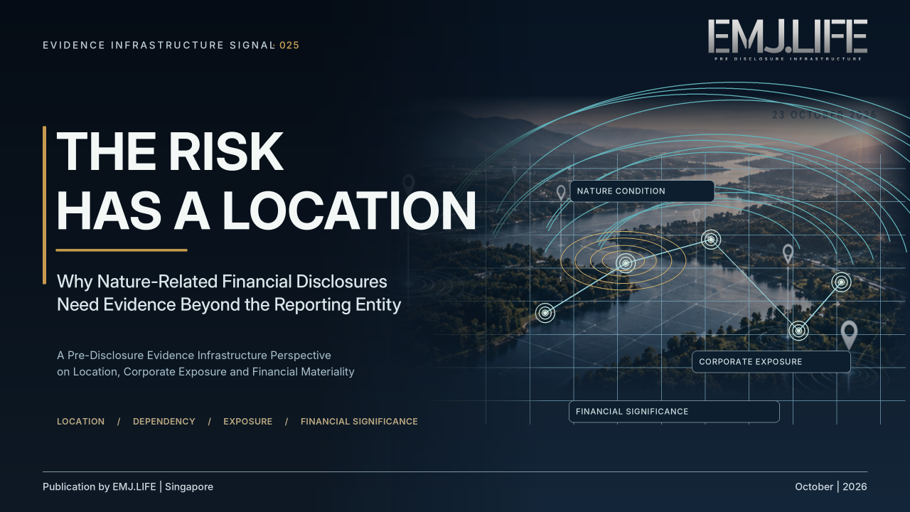
Where nature-related risks emerge, financial significance must still be proven.
EVIDENCE INFRASTRUCTURE SIGNAL · 025
THE RISK HAS A LOCATION
Why Nature-Related Financial Disclosures Need Evidence Beyond the Reporting Entity
A Pre-Disclosure Evidence Infrastructure Perspective on Location, Corporate Exposure and Financial Materiality

Executive Summary
On 22 October 2026, the International Sustainability Standards Board (ISSB) released an Exposure Draft proposing IFRS Sustainability Disclosure Practice Statement 1: Nature-related Disclosures.
The proposals address nature-related risks and opportunities that could reasonably be expected to affect an entity's cash flows, access to finance or cost of capital.
They build on IFRS S1 and IFRS S2, including specific considerations concerning the location of assets and activities throughout the value chain, characteristics of nature in those locations, and the appropriate geographical scale of disclosures. [1]
This is not a new mandatory global nature-reporting standard.
IFRS S1 already requires material information about relevant sustainability-related risks and opportunities, including those related to nature. The proposed Practice Statement would provide supplementary requirements for entities applying it, and a jurisdiction could choose to require its use.
Nevertheless, the consultation introduces a significant evidence question.
A nature-related risk may originate at a specific location, but its financial significance cannot be established from location data alone.
A water-stressed basin does not automatically establish material financial risk for every company operating within it.
A facility in an ecologically sensitive area does not automatically represent a material exposure.
Conversely, risks arising through suppliers, shared natural resources or interconnected locations may affect an enterprise even where the relevant environmental condition is not present at its own facilities.
The ISSB's accompanying illustrative guidance makes the distinction unusually clear.
The appropriate level of disclosure depends not only on environmental conditions, but also on the affected operations, their significance to the business, the potential consequences of disruption and the entity's ability to respond. [3]
Viewed through a Pre-Disclosure Evidence Infrastructure perspective, this raises a broader question:
How can location-specific environmental information become decision-useful corporate financial information without losing the relationships and context necessary to support that conclusion?
This Signal examines the evidence chain between place, nature, dependency, exposure, financial transmission and reporting-entity materiality.
It does not propose that all risks require precise geographical coordinates, or that identifying a sensitive location is sufficient to establish a financial conclusion.
The emerging institutional challenge is not simply to collect more location data.
It is to preserve the evidence explaining why a particular location matters to a particular enterprise.

Opening Signal
A Risk Can Be Located Without Being Financially Established
A manufacturing company operates several facilities across different markets.
Some draw water from rivers.
Others depend on groundwater.
Its suppliers may rely on agricultural landscapes, forests or ecosystems hundreds of kilometres away.
Environmental conditions can be observed, modelled and compared across these locations.
But does a water-stress indicator tell an investor whether the company's earnings are at risk?
Not necessarily.
Two facilities operating in the same water-stressed basin may face very different financial consequences.
One may have alternative water sources, transferable production and limited commercial significance.
The other may supply a critical market, depend on one source of water and require substantial investment to relocate production.
The environmental condition may be similar.
The enterprise exposure is not.
On 22 October 2026, the ISSB's new nature-related disclosure consultation brought this distinction into sharper focus.
The proposal calls for consideration of location-related characteristics when identifying nature-related risks and opportunities, and when determining what information should be disclosed.
It also asks preparers to consider the appropriate geographical scale and the aggregation or disaggregation of material information. [1]
The institutional problem is therefore more demanding than attaching a location to an environmental metric.
It requires evidence of how nature, operations and financial prospects are connected.
The risk has a location.
Its financial significance still requires proof.

01 | Location Is Not Yet Financial Risk
A geographical observation can establish an important environmental condition.
It may identify water scarcity, declining ecosystem integrity, soil degradation or proximity to a sensitive habitat.
But those observations do not necessarily establish how a specific corporation is exposed.
Consider the difference between three statements:
Environmental condition: A river basin is experiencing heightened water stress.
Corporate dependency: A company's manufacturing facility depends on freshwater from that basin.
Financial exposure: Interruption of the water supply could materially affect the company's production, operating costs or ability to serve a market.
Each statement requires different evidence.
The first concerns the condition of an environmental resource.
The second concerns the relationship between that resource and a business activity.
The third concerns the possible consequences for the reporting entity.
The distinctions matter because the first statement cannot automatically establish the second or third.
The World Resources Institute's Aqueduct 4.0 provides a useful independent example.
Aqueduct translates hydrological datasets into comparable water-risk indicators covering matters such as water stress, depletion and variability.
However, WRI explicitly cautions that composite measures such as overall water risk cannot be directly measured and independently validated in the same manner as individual observations.
Aqueduct is primarily a screening and prioritisation tool that should be supplemented by local and regional analysis. [5]
This does not diminish the importance of geospatial indicators.
It clarifies their evidentiary purpose.
A screening tool can help identify where further investigation is warranted.
It does not, by itself, establish the financial implications for an individual corporation.
The same distinction applies beyond water.
Proximity to an important ecosystem, exposure to land degradation or operations within a regulated landscape may provide relevant context.
But the significance of that context depends on how the entity interacts with the location and whether resulting risks or opportunities could reasonably affect its prospects.
Environmental sensitivity is not identical to corporate financial materiality.

02 | The Enterprise Does Not End at Its Facilities
The location problem becomes more complex when an enterprise operates through an extended value chain.
A manufacturer may depend on raw materials from one region, processing capacity in another and suppliers operating within several different ecosystems.
A financial institution may be exposed through borrowers or investees whose activities depend on natural resources in distant locations.
A food producer may rely on agricultural productivity across multiple watersheds.
These dependencies may not be visible from the geographical distribution of the reporting entity's owned facilities.
IFRS S1 already recognises that an entity's prospects are connected to its dependencies on resources and relationships throughout the value chain. [4]
The proposed nature-related Practice Statement would add specific consideration of location when identifying nature-related risks and opportunities.
Paragraph 10 and application guidance B26–B36 address locations of assets and activities throughout the value chain, including environmental, social, legal and regulatory characteristics. [1]
This introduces a critical identification problem.
A legal entity, production facility, supplier, watershed and ecosystem are not equivalent reference objects.
They may overlap.
But they cannot be substituted for one another.
A single facility may depend on several natural resources.
Multiple facilities may share the same watershed.
A supplier may operate several sites.
An ecological disturbance may originate outside the boundaries of an enterprise's direct operations.
Some risks may also arise through broader regulatory or market changes rather than a single identifiable site.
Reliable assessment therefore requires more than a list of facility coordinates.
It requires relationships between business activities, resource dependencies, affected locations, relevant counterparties and the legal or operational conditions under which exposure arises.
The same environmental event may affect several entities differently.
Conversely, several geographically distinct events may combine to create a material concentration of risk for one reporting entity.
This is why location-specific evidence and entity-level disclosure should be connected, but not confused.

03 | The Financial Transmission Question
What Turns a Place-Based Condition Into an Entity-Level Concern?
For nature-related information to become decision-useful, the reporting entity needs to consider how a condition could affect its business model and prospects.
A water-related disruption, for example, may affect an enterprise through reduced output, more expensive water treatment, additional capital expenditure, substitution costs or interrupted supply.
But the significance of those channels depends on circumstances.
How much production depends on the facility?
Can the activity be transferred?
How long would substitution take?
Are alternative water sources available?
Would an interruption affect a strategically important market?
Could regulatory changes restrict continued operations?
Are the relevant consequences reasonably expected to affect the entity's cash flows, access to finance or cost of capital?
These questions connect environmental evidence to economic exposure.
They do not require that every potential effect already be expressed as a precise monetary estimate.
Rather, the assessment must retain the assumptions, uncertainties and business relationships necessary to explain the conclusion.
The ISSB proposals also address nature-related scenario analysis, including relevant inputs, time horizons, locations, assumptions and the ability of an entity to adjust its business model. [1]
This reinforces the importance of distinguishing observed conditions from modelled possibilities.
A projected environmental change is not an observed financial loss.
A scenario is not a forecast that an event will necessarily occur.
A possible operational disruption is not necessarily material to the reporting entity.
Each transition requires a defensible basis.
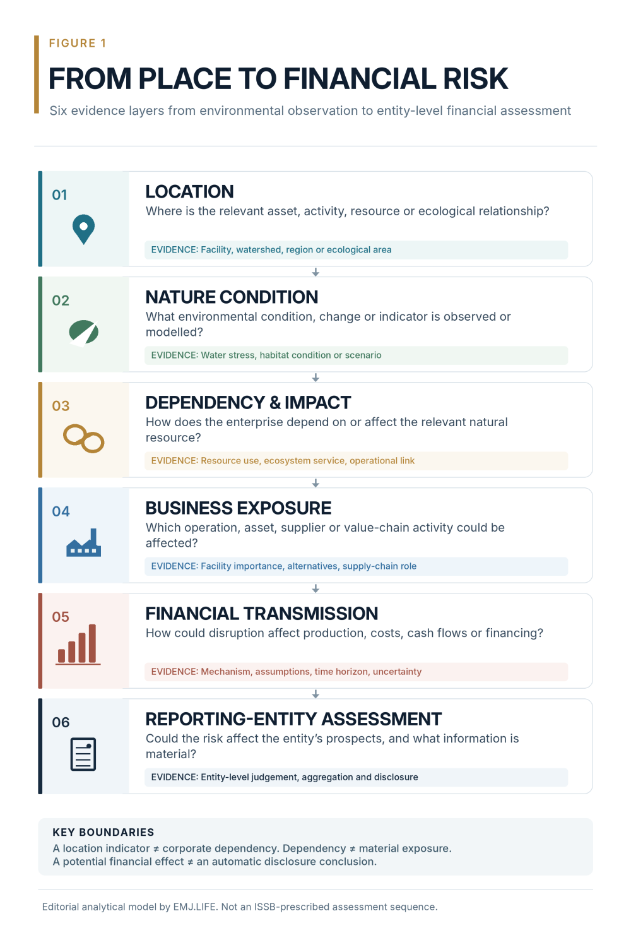
Six evidence layers connect location conditions to corporate financial exposure.

04 | When Aggregation Conceals Material Information
The Right Scale Is Not Always the Smallest Scale
One of the most important elements of the ISSB consultation concerns geographical scale.
The proposed application guidance does not prescribe one geographical resolution for every disclosure.
Depending on the circumstances, relevant information might concern an individual site, a watershed, a region or an area extending across national boundaries. [1]
This creates two opposite risks.
Excessive aggregation can conceal the concentration of significant exposure.
A critical production facility may disappear into a regional average even though its disruption could materially affect the company.
Excessive disaggregation can conceal common exposure.
A group of individually less significant facilities may collectively face a material risk, even though each facility appears unimportant when viewed separately.
The ISSB's accompanying guidance illustrates both problems through a hypothetical manufacturer, Entity A. [3]
Entity A operates facilities in several markets and requires reliable access to freshwater.
The example considers three different situations.
A Group of Similarly Exposed Facilities
Several facilities in Region A obtain water from different basins where scarcity is increasing.
They have comparable production processes and some flexibility to transfer production.
Disruption at any one facility would not independently be expected to affect the entity's prospects.
However, disruption across several facilities could collectively reduce production and increase costs.
Entity A determines that the common exposure is material on an aggregated regional basis.
Separate disclosure of every facility could obscure the collective risk.
A Critical Facility With Distinct Exposure
Another facility supplies specialised components to an important market.
It depends principally on one water source in Basin D, where water stress and competing demand are increasing.
Alternative water sources are limited, and transferring production would require substantial expenditure and time.
The location is relevant.
But it is the combination of water dependency, the facility's business significance and limited alternatives that makes the risk materially different from the other facilities.
Entity A therefore presents information about this concentration separately at the facility and basin level.
Facilities Without a Relevant Identified Risk
Other facilities have reliable access to water of the required quality from more than one source.
Based on the information considered, Entity A does not identify a water-related risk associated with those facilities that could reasonably be expected to affect its prospects.
The example does not require each such facility to be separately disclosed merely because it has a geographical location.
These distinctions demonstrate an important principle.
More granular information is not always more decision-useful.
The relevant question is whether the level of detail helps users understand the nature, concentration and possible financial consequences of an exposure.
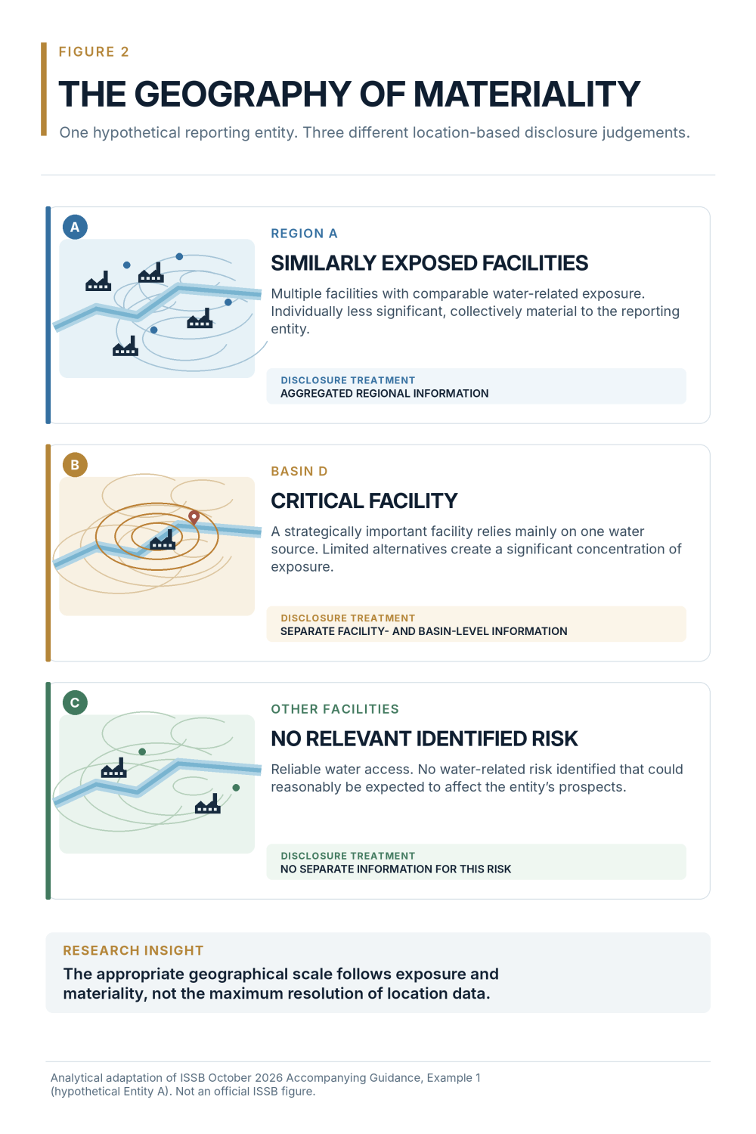
One entity, three location scenarios, different disclosure treatments.
05 | The Limits of Location-Based Evidence
Location-specific analysis introduces important technical and institutional limits.
Environmental data can differ in resolution, collection method, observation period and uncertainty.
A global model may identify a regional priority without capturing every local operational or regulatory condition.
A satellite-derived indicator may describe land cover without establishing how a facility's business model depends on that land.
A supplier's reported location may not identify where an important production activity actually occurs.
A geographical concentration may also change over time as sourcing patterns, production capacity or ecological conditions evolve.
These differences matter when data from multiple systems are combined.
Aqueduct illustrates the issue.
Its global framework is designed to support comparable water-risk screening, but WRI acknowledges methodological limitations and recommends deeper local analysis for priority locations. [5]
Therefore, the availability of a location score should not be interpreted as sufficient evidence of financial exposure.
The proposed ISSB Practice Statement addresses proportionality by allowing the use of reasonable and supportable information available without undue cost or effort in the relevant circumstances. [1]
This is not equivalent to requiring perfect location data before a company can assess nature-related risks.
Nor is it permission to treat unsupported assumptions as verified facts.
A defensible assessment should distinguish the information that is known, the assumptions used, the uncertainty that remains and the significance of those limitations.
Environmental Location Is Also a Social and Regulatory Context
The location of a business activity can matter for reasons extending beyond ecological measurements.
Natural resources may be subject to rights, access arrangements, competing uses and legal restrictions.
Indigenous Peoples, Local Communities and affected stakeholders may have relationships with the same resources on which an enterprise depends.
The proposed Practice Statement addresses these considerations when identifying and disclosing nature-related risks and opportunities. [1]
A river is therefore not only a hydrological feature.
For an enterprise, it may also be a source of operational dependency, a regulated resource and an area involving other parties' rights and interests.
Those dimensions must not be collapsed into a single environmental score.
At the same time, financial materiality under the ISSB framework should not be confused with an independent claim that every environmental or social impact is financially material.
The purposes and boundaries of the assessment remain distinct.

06 | Nature and Climate Evidence May Intersect Without Becoming Equivalent
Another important feature of the ISSB proposals concerns connections between nature-related and climate-related risks and opportunities.
Climate change may influence water availability, ecosystem condition and the frequency or severity of certain physical hazards.
Nature-related changes may also alter climate vulnerability.
Corporate responses can produce synergies or trade-offs.
For example, a nature-related risk-management strategy might involve protecting wetlands that also provide flood-mitigation benefits.
Conversely, some investments intended to address climate-related risks could introduce different nature-related dependencies or impacts.
The proposed Practice Statement calls for connected information and seeks to avoid unnecessary duplication where entities manage related risks together. [1]
But connection should not be mistaken for equivalence.
A climate-related hazard indicator does not necessarily measure ecosystem condition.
A biodiversity observation does not automatically establish a climate-related financial effect.
And an integrated management response does not eliminate the need to preserve the distinct assumptions and evidence relevant to each risk.
This is especially important when nature and climate models rely on different data sources, scenarios or geographical scales.
An entity may appropriately present a connected explanation while maintaining separate evidence for the underlying environmental conditions.
The objective is not to force two analytical domains into one metric.
It is to prevent relevant connections from being lost between them.

07 | What Changes Before Disclosure?
The Upstream Evidence Question
The emerging challenge is not limited to the format of a published nature-related disclosure.
A reporting entity may ultimately provide a concise account of a material risk.
But that account can depend on information formed across different locations, systems, periods and business relationships.
A regional water-risk assessment may draw on geospatial datasets.
Facility-level exposure may depend on operating records, sourcing arrangements and production capabilities.
Value-chain analysis may rely on information supplied by counterparties.
Financial assessment may require management assumptions, scenario inputs and relevant business forecasts.
The eventual disclosure may contain only the information judged material to the reporting entity.
This creates an upstream evidence-governance question:
Can the organization preserve the relationships necessary to explain how the reported conclusion was reached?
Viewed through a Pre-Disclosure Evidence Infrastructure perspective, a useful evidence architecture may need to maintain:
Location and Scale
The site, basin, region or other relevant geographic or ecological reference, including the scale and limitations of the location information.
Source and Observation Context
The source, date, method, resolution, scenario assumptions and uncertainty of environmental information.
Corporate Attribution
The relevant entity, facility, supplier, business activity or value-chain relationship to which the information relates.
Dependency and Exposure
The basis for connecting natural-resource conditions to a specific business dependency, potential disruption or opportunity.
Financial Assessment Context
The assumptions used to assess potential business consequences, including alternatives, sensitivity, concentration and relevant financial transmission channels.
Disclosure Judgement
The reasons for aggregating, disaggregating or excluding particular information, with appropriate record of authority, materiality considerations and applicable rights or restrictions.
These are proposed evidence-governance capabilities, not mandatory data fields prescribed by the ISSB.
They also do not require every organization to publish precise facility coordinates or disclose sensitive upstream records.
The draft specifically leaves the appropriate geographical scale dependent on an entity's facts and circumstances.
What matters for this analysis is the separation between evidence retained for legitimate internal assessment and information appropriately disclosed to external users.
A company may disclose material information at regional scale while retaining more detailed records under applicable controls.
Alternatively, a regional assessment may be the most specific information reasonably and supportably available.
Neither situation independently establishes a compliance failure.
The research question is whether the resulting disclosure remains understandable and supportable within the applicable standards, assumptions and information constraints.
A Structural Signal, Not a Technology Mandate
TNFD's LEAP v2.0 provides an additional reference for the relationship between location, dependencies, impacts, risks and opportunities.
Its Locate, Evaluate, Assess and Prepare phases offer a structured approach to nature-related assessment. [6]
The ISSB drew upon TNFD materials in developing its proposed Practice Statement.
However, the ISSB does not require every entity to apply LEAP in order to assert compliance with the proposed Practice Statement or IFRS Sustainability Disclosure Standards. [2]
The two frameworks have distinct purposes and requirements.
Likewise, the proposed ISSB disclosures do not mandate one universal geospatial database, evidence platform or machine-readable provenance architecture.
The broader implementation lesson is more limited and more important.
As nature-related information becomes more closely connected to financial decision-making, the quality of the relationship between environmental observations and corporate exposure may become increasingly significant.
Machine-readable locations can help identify where evidence belongs. They do not automatically establish what that evidence means for a reporting entity.

Closing Signal
The Place Is Known. Is the Exposure Proven?
The October 2026 ISSB consultation highlights a structural problem that cannot be solved by environmental mapping alone.
A company can identify its facilities.
It can observe natural-resource conditions.
It can locate suppliers.
It can measure water stress, model ecosystem change and document environmental dependencies.
But none of these activities independently establishes a material financial conclusion.
The reporting entity must still consider how location-specific conditions interact with its business model, operations, value chain, capacity to respond and financial prospects.
Sometimes information about one critical facility will matter.
Sometimes collective exposure across many facilities will matter more.
Sometimes a sensitive location will not give rise to a risk that could reasonably be expected to affect the enterprise's prospects.
The appropriate disclosure is not necessarily the most geographically detailed disclosure.
It is the disclosure that preserves the distinctions necessary for users to understand the relevant risk.
This is the deeper Evidence Infrastructure implication.
The location of a risk may be identifiable.
Its financial meaning depends on relationships that still need to be established.
A risk has a location.
Its significance has an evidence chain.

Methodological Boundary
This Signal is an independent institutional interpretation of developments published during October 2026.
Its principal event is the ISSB's Exposure Draft of 22 October 2026. The consultation closes on 19 February 2027.
The Exposure Draft is not an effective IFRS Sustainability Disclosure Standard. The proposed Practice Statement would supplement the application of IFRS S1 and IFRS S2, and its use would not be a universal prerequisite for compliance with those Standards. Jurisdictions may determine whether to require its application after issuance.
The ISSB's Entity A example is hypothetical and does not establish actual corporate financial exposure. Figure 2 is an original editorial interpretation of that example, not an official ISSB figure.
Figure 1 is an analytical model proposed for examining evidence relationships. It does not represent a mandatory regulatory workflow or internationally adopted evidence taxonomy.
WRI Aqueduct, TNFD LEAP and IFRS Sustainability Disclosure Standards serve different purposes. Their separate institutional roles and materiality boundaries are preserved throughout this analysis.
This publication does not claim that location mapping, environmental-risk screening or evidence infrastructure independently establishes financial materiality, regulatory compliance, external assurance or actual environmental outcomes.
The views expressed are an independent Evidence Infrastructure interpretation and do not imply endorsement by the IFRS Foundation, ISSB, TNFD or WRI.

Official Sources and Research References
[1] International Sustainability Standards Board (2026).
Exposure Draft ISSB/ED/2026/1: IFRS Sustainability Disclosure Practice Statement 1, Nature-related Disclosures.
October 2026. Particularly paragraphs 3–4, 10, 15–18, 30–33 and B26–B42.
Official Exposure Draft
[2] International Sustainability Standards Board (2026).
Basis for Conclusions on Exposure Draft IFRS Sustainability Disclosure Practice Statement 1: Nature-related Disclosures.
October 2026. Particularly BC94–BC120 and BC194–BC220.
Official Basis for Conclusions
[3] International Sustainability Standards Board (2026).
Accompanying Guidance on Exposure Draft IFRS Sustainability Disclosure Practice Statement 1: Nature-related Disclosures.
October 2026. Example 1, paragraphs IE6–IE28.
Official Illustrative Examples
[4] IFRS Foundation (2023).
IFRS S1: General Requirements for Disclosure of Sustainability-related Financial Information.
Official Standard Information
[5] World Resources Institute (2023).
Aqueduct 4.0: Updated Decision-Relevant Global Water Risk Indicators.
Technical Note, 16 August 2023.
Official WRI Research
WRI Aqueduct 4.0 Dataset
[6] Taskforce on Nature-related Financial Disclosures (2026).
Guidance on the Identification and Assessment of Nature-related Issues: The LEAP Approach, v2.0.
October 2026.
Official TNFD LEAP Guidance

Related Evidence Infrastructure Research
This Signal preserves the analytical boundaries developed in two related publications:
Evidence Infrastructure Signal 024: The Action Is Not the Outcome, which distinguishes activity records, environmental outcomes and contribution claims.
Evidence Infrastructure Analysis 022: ONE ENTITY, MULTI EVIDENCE HISTORIES, which examines how independently governed evidence histories may become traceably related without losing their source and responsibility boundaries.
EIS-025 extends that research discipline to a different question: whether location-specific nature evidence can support conclusions about a reporting entity's financial risks and opportunities.

