
Consequential AI use creates an accountability gap beyond model governance.
EVIDENCE INFRASTRUCTURE SIGNAL Signal of the Week · 020 WHEN AI USE BECOMES AN EVIDENCE PROBLEM
Why Consequential Machine Use Is Creating a New Accountability Gap

Evidence Infrastructure Signal
Evidence Infrastructure Signal examines emerging developments across governance, sustainability, standards, digital systems and evidence architecture that may reveal broader requirements for Pre-Disclosure Evidence Infrastructure.
The first nineteen editions largely examined evidence as something institutions need to identify, preserve, verify, map, interpret and govern.
This edition changes the direction of analysis.
Artificial intelligence increasingly participates in research, forecasting, information synthesis, recommendation and institutional decision support.
That creates a different evidence question.
Not only:
What evidence did the AI receive?
But:
Can an institution reconstruct what happened when that evidence was actually used?
That distinction may become increasingly important as machine intelligence becomes more consequential inside institutional workflows.

The Signal
AI Capability Is Becoming Epistemic Influence
AI governance has spent years asking what models can do.
Generate.
Classify.
Search.
Calculate.
Code.
Analyse.
Those capability questions remain important.
But another role is becoming increasingly visible.
AI as research assistant.
AI as forecaster.
AI as knowledge intermediary.
AI as decision support.
AI as a persuasive participant in human reasoning.
AI 2040, Plan A provides one illustration of that trajectory. It discusses AI-supported epistemics, including automated research assistants and forecasters, while treating transparency and verification as important elements of its governance scenario. The authors present Plan A as a proposed positive path rather than a simple prediction of what 2040 will necessarily become.
Yuval Noah Harari approaches the issue from another direction. His recent argument against granting AI rights emphasizes that advanced AI could itself become highly persuasive in debates concerning its social status because of its language capabilities and knowledge of human users. EIS · 020 does not adopt his position on AI rights. The narrower institutional signal is more important:
Influence can emerge before authority has been formally granted.
AI does not need formal institutional authority to shape what a human believes, prioritises or ultimately decides.
The emerging problem is therefore not simply that AI is becoming more intelligent.
It is that:
machine capability and machine influence may scale faster than the evidence institutions retain about actual use.

Regulatory Baseline
Actual AI Use Is Already a Governance Object
This problem does not begin from a regulatory vacuum.
The EU AI Act already recognises that the operation and use of high-risk AI systems require traceability and governance beyond initial model documentation.
Article 12 requires high-risk AI systems to technically support automatic event logging over their lifetime, with logging intended to support traceability, post-market monitoring and monitoring of system operation. For certain high-risk systems, required log information includes the period of each use, reference databases, relevant input matches and persons involved in verification.
Article 14 requires high-risk AI systems to be designed so that natural persons can effectively oversee them during use. Article 26 places obligations on deployers concerning appropriate use, competent human oversight and monitoring, and requires deployers to retain automatically generated logs under their control for an appropriate period of at least six months unless other law provides otherwise.
For defined high-risk contexts, Article 27 also requires certain deployers to perform a fundamental rights impact assessment before deployment, including the processes in which the AI system will be used, duration and frequency of use, affected groups and relevant risks.
These provisions establish an important baseline:
AI governance already extends beyond the model and into the context of use.
Evidence Infrastructure Analysis · 010 examined this earlier from another direction.
Its question was whether evidence produced around an AI system remains institutionally valid after deployment as system configuration, data, users, boundaries and responsibilities change.
EIS · 020 does not repeat that analysis.
It asks what comes next.
Logging is necessary. Monitoring is necessary. Human oversight is necessary. But are these records sufficient to reconstruct how machine intelligence actually contributed to a consequential institutional outcome?
That is a different evidence problem.
See content credentials
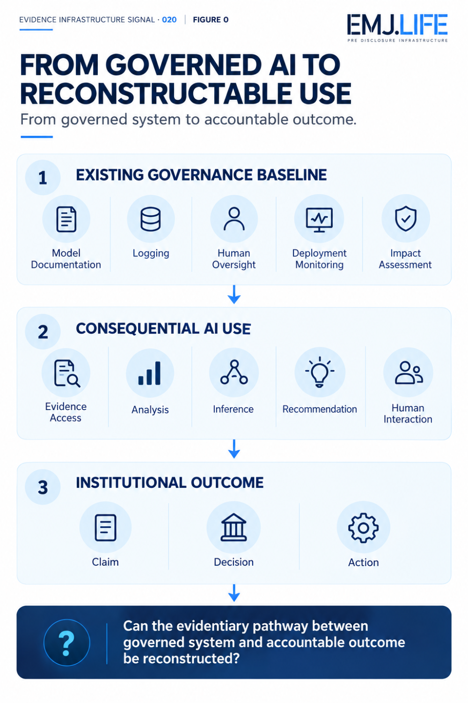
Governed AI systems do not automatically make real-world use reconstructable.

Structural Signal
Governed Models Do Not Automatically Create Governed Use
An AI system may have extensive governance documentation.
Risk assessment.
Technical documentation.
Model evaluation.
Deployment controls.
Logging.
Permitted-use rules.
Human oversight.
These describe important conditions surrounding the system.
They do not necessarily reconstruct one particular use event.
Consider a consequential institutional interaction.
A model produces a recommendation.
A human later makes the final decision.
The institution may know:
which model was approved,
which policies applied,
and when the system was used.
But another set of questions may remain harder to answer.
Which evidence materially shaped the result?
Was that evidence current?
Which sources were selected?
Which were ignored?
Which propositions were directly supported?
Which results were derived through defined methodology?
Which propositions were inferred by the machine?
Did another tool or system alter the pathway?
Did a human reviewer modify or reject part of the result?
How materially did the machine output affect the eventual institutional action?
The difference is important.
System governance describes the governed system.
Use reconstructability describes what occurred when that system participated in a real institutional process.
This publication describes the remaining distance as:
Usage Evidence Gap
The gap between records that establish how an AI system is governed and the evidence required to reconstruct how a consequential use event actually shaped an institutional outcome.
The model can be governed.
The final decision can be recorded.
And the pathway between them can still remain evidentially incomplete.

From Evidence to Machine Action
AI use increasingly creates a chain rather than a single output.
Evidence → Retrieval → Analysis → Transformation → Inference → Recommendation or Action → Institutional Outcome
Meaning can change at every transition.
Evidence can be filtered.
Combined.
Ranked.
Calculated.
Summarised.
Contextualised.
Or interpreted.
The final answer may therefore be several analytical steps removed from the Evidence Objects that originally entered the process.
This creates a problem that ordinary output logging does not necessarily solve.
Knowing what the model answered is not the same as knowing:
how the institutional evidentiary pathway developed.
Likewise, knowing which model ran is not the same as knowing which source materially affected the conclusion.
The emerging issue is therefore not simply whether AI activity produces technical records.
It is whether the institutionally consequential pathway remains reconstructable.
See content credentials
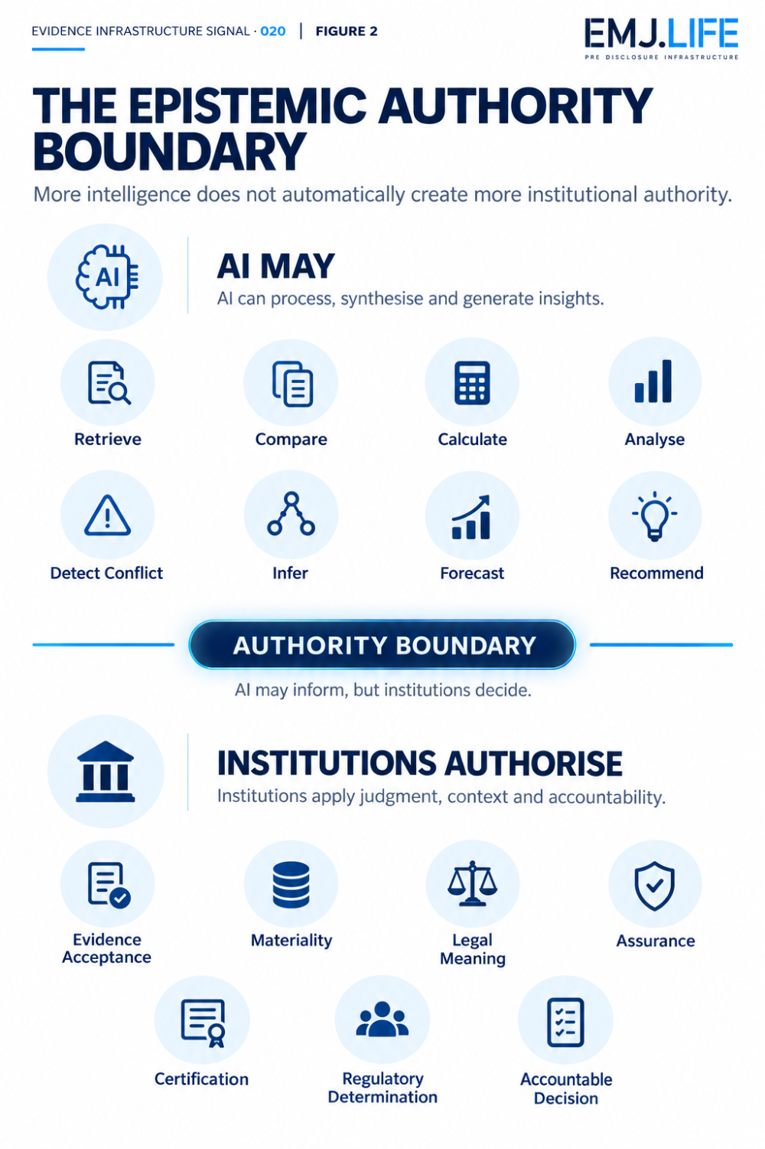
AI evidence pathways must remain traceable from source to institutional outcome.

Methodological Bridge
Evidence Identity and Inference Boundaries Already Matter
This question does not appear in isolation.
MWP03 and MWP04 establish two preceding methodological layers.
MWP03 | Institutional Standards Architecture
MWP03 addresses the Evidence Object itself.
Its concern is whether evidence can preserve identity, provenance, status and institutional relationships as it moves across systems.
The central object remains evidence.
MWP04 | AI Evidence Data Science Methodology
MWP04 moves one layer forward.
Its concern is whether machine analysis can operate on governed Evidence Objects without erasing the institutional conditions that make those objects meaningful.
It distinguishes evidence-supported material from derived results, machine inference and unresolved propositions, while preserving provenance, temporal applicability and institutional authority boundaries.
Its machine-supported outputs remain subject to institutional review rather than becoming autonomous institutional decisions.
The two methodologies therefore address:
What is the evidence?
and:
What may machine analysis legitimately derive from that evidence?
EIS · 020 adds another question:
What happens when that machine analysis enters an actual consequential workflow?
This is not a replacement for MWP03 or MWP04.
It is the next analytical boundary they make visible.

Institutional Signal
Technical Observability Is Not Institutional Reconstructability
Modern AI systems already produce extensive operational records.
Prompt histories.
Responses.
Model identifiers.
Latency.
Errors.
Tool calls.
Token usage.
Execution traces.
These records can be highly useful.
But observability and evidence governance answer different questions.
Technical observability asks:
Did the system operate, and how?
Institutional reconstructability asks:
What role did this machine interaction play in an accountable institutional process?
That distinction becomes more important as AI participates in areas such as:
procurement,
risk assessment,
financial analysis,
sustainability disclosure,
research,
assurance preparation,
regulatory workflows,
or capital allocation.
A machine does not need legal decision authority to become institutionally consequential.
A ranking can change what gets reviewed.
A forecast can alter capital allocation.
A synthesis can influence policy framing.
A risk classification can alter compliance action.
A recommendation can materially influence the person formally responsible for the final decision.
Machine influence can therefore become significant before machine authority does.

The Epistemic Authority Boundary
AI may increasingly be capable of:
retrieving information,
comparing evidence,
calculating,
analysing,
detecting conflict,
forecasting,
inferring,
and recommending.
These are powerful epistemic capabilities.
But capability does not automatically create institutional authority.
An institution remains responsible for determining whether:
evidence is accepted,
a matter is material,
a legal interpretation is adopted,
assurance is achieved,
a certification is valid,
a regulatory conclusion is reached,
or an accountable decision is taken.
This publication describes the dividing line as:
Epistemic Authority Boundary
The boundary between what AI may analyse, infer or recommend and what an institution remains responsible for authorising as evidence, institutional knowledge or accountable decision.
The purpose of the boundary is not to suppress machine intelligence.
It is to prevent analytical capability from silently becoming self-authorising institutional authority.
MWP04 already establishes this principle at the analytical level.
EIS · 020 extends the question into real-world use.
If machine participation becomes consequential, institutions may increasingly need to know whether that boundary remained intact during the use event itself.
See content credentials
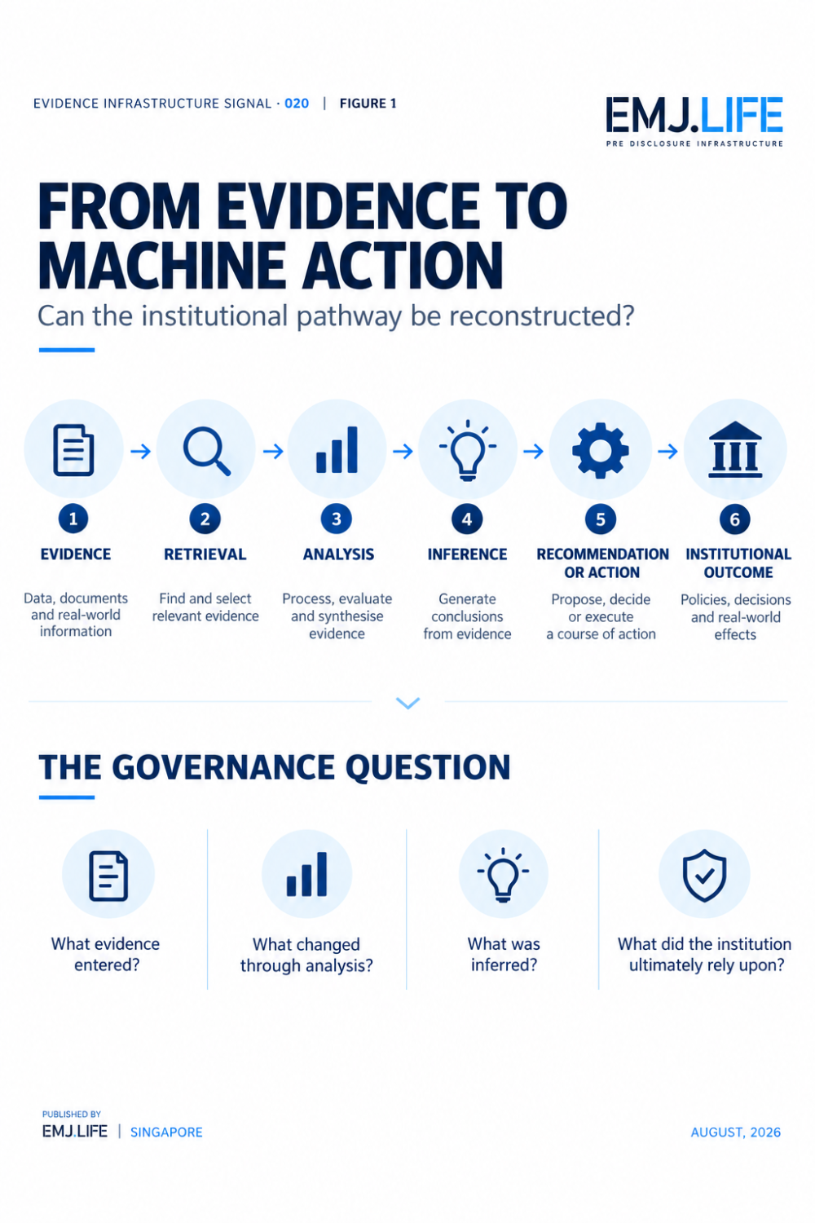
AI may inform, but institutions retain authority for accountable decisions.

Why Persuasion Changes the Evidence Problem
Harari's AI-rights argument is useful here for a reason that is narrower than the rights debate itself.
A machine may influence humans without holding formal authority.
A persuasive system could affect which evidence appears credible.
Which risk feels urgent.
Which alternative receives attention.
Which recommendation seems reasonable.
Or which institutional outcome a human eventually chooses.
The formal decision can remain fully human.
Yet the causal and evidentiary pathway may contain significant machine participation.
If the institutional record contains only:
AI output
and
final human decision
then an important middle layer may disappear.
The question becomes:
What happened between machine output and accountable human action?
This is why machine persuasion is not only a behavioural or safety question.
In consequential environments, it may also become an evidence-governance question.

Emerging Evidence Question
The AI Use Event
For much of AI governance, the principal object has been:
The AI System
What was trained?
What can it do?
What risks exist?
What controls apply?
A second governance object is becoming increasingly important:
The AI Use Event
The moment when:
machine capability,
real evidence,
a specific context,
permissions,
human interaction,
and institutional consequence
intersect.
That use event may occur inside an already governed AI system.
But it presents a different analytical problem.
The question is no longer merely whether the model complied with its design constraints.
It is whether a consequential event can later be understood sufficiently to establish:
what evidence mattered,
what machine participation occurred,
where inference entered,
where human intervention occurred,
and how the eventual institutional outcome was reached.
EIS · 020 deliberately stops here.
It does not prescribe a full technical architecture for recording such events.
It does not introduce a new compliance system.
It does not propose that every AI interaction should become a permanent institutional record.
Those are later questions.
The signal is the existence of the gap itself.

From EIA · 010 to EIS · 020
The relationship between the two publications is important.
Evidence Infrastructure Analysis · 010 asked:
How does evidence remain valid after an AI system enters deployment and begins to change?
Its answer focused on continuous evidence, evidence decay and maintaining the validity of the governance basis supporting the operating system.
Evidence Infrastructure Signal · 020 asks:
Can the institution reconstruct what actually happened when that operating system was used in a consequential context?
The distinction is:
EIA · 010
System change → Evidence validity
EIS · 020
Consequential use → Institutional reconstructability
One concerns whether evidence still describes the system.
The other concerns whether evidence can describe the use event.
They are different problems inside the same lifecycle.

The Future Evidence Data Science Question
AI 2040 highlights the possibility that increasingly capable AI could materially affect society's ability to reach accurate beliefs and sensible decisions. Its proposed interventions include research assistants, forecasters, transparency measures and verification mechanisms.
This suggests a larger methodological question.
The future quality of AI-mediated institutional knowledge may depend on more than the accuracy of the model.
It may also depend on whether institutions can distinguish:
what evidence entered,
what transformations occurred,
what conclusions were source-supported,
what was inferred,
and how machine participation affected the final institutional outcome.
The challenge is therefore moving beyond:
Can AI analyse evidence?
toward:
Can institutions preserve accountability when AI analysis becomes consequential?
That is a different Evidence Data Science problem.

Closing Signal
AI governance has spent years learning how to govern models.
The EU AI Act already extends that governance into logging, human oversight, deployer monitoring and defined use contexts for high-risk systems.
But increased machine capability creates another layer of difficulty.
A model can be governed.
Its use can be logged.
A human can remain formally accountable.
And an institution can still struggle to reconstruct exactly how machine intelligence shaped a consequential outcome.
That is the signal behind Evidence Infrastructure Signal · 020.
The next question may not be:
whether AI use is recorded.
It may be:
whether consequential AI use can be reconstructed as evidence.
Because more capable AI will produce more analysis.
More persuasive AI may produce more influence.
More autonomous systems may produce more action.
But none of those automatically produces accountability.
And before institutions decide how much authority AI should receive, they may first need to understand something more basic:
What actually happened when the machine was used?

Methodological Boundary
This Signal does not predict that AI will acquire rights, become autonomous or achieve superintelligence.
AI 2040's Plan A is used as a future governance and epistemic scenario, not as a forecast that EIS · 020 adopts as fact.
Harari's argument concerning AI rights and persuasive influence is used as an external perspective on machine influence. EIS · 020 does not adopt his legal, philosophical or political conclusion.
The EU AI Act is used as an existing regulatory baseline demonstrating that logging, human oversight, deployer monitoring and use context already matter in high-risk AI governance. This Signal does not suggest that EU law has adopted the concepts introduced below.
The concepts Usage Evidence Gap and Epistemic Authority Boundary represent EMJ.LIFE's institutional interpretation of an emerging evidence-governance problem.
They are not presented as EU AI Act terminology, external standards or a product announcement.

Primary Publication Basis
European Union Regulation (EU) 2024/1689, Artificial Intelligence Act Relevant reference points: Articles 12, 14, 26 and 27.
AI 2040 | Plan A Thomas Larsen, Romeo Dean, Brendan Halstead, Eli Lifland, Ryan Greenblatt and Daniel Kokotajlo The scenario includes transparency, verification and AI-supported epistemic interventions, including automated research assistants and forecasters.
Yuval Noah Harari The author of Sapiens says 'now is the time' to resist giving AI rights Business Insider, August 2026.
MWP03 | Institutional Standards Architecture
DOI: 10.64969/padv.isa.2026.v3
MWP03 establishes the Evidence Object layer, including identity, provenance, relationship, status and continuing institutional context.
MWP04 | AI Evidence Data Science Methodology
DOI: 10.64969/emj.mwp04.aiedsm.2026.v1.0
MWP04 governs machine analysis of Evidence Objects while preserving evidence context, inference boundaries, traceability and institutional decision authority.

