Evidence Infrastructure Signal · 002
Why Interoperability Also Requires Boundaries
May 17, 2026
Observations on governance separation, evidence integrity and sustainability infrastructure systems.
What initially appeared to be separate conversations around sustainability reporting, assurance systems, AI-enabled analysis, digital disclosures and operational data environments may increasingly be converging toward another structural challenge:
how can governance boundaries remain clear across increasingly interconnected sustainability ecosystems?
As IFRS/ISSB, ESRS, GRI, COSO assurance providers, enterprise software systems and AI-enabled sustainability workflows continue evolving simultaneously, interoperability is becoming increasingly important across disclosure and operational environments.
However, greater connectivity may also introduce new forms of structural ambiguity.
This appears to be shifting the conversation beyond interoperability alone.
The emerging challenge is increasingly about:
- governance separation
- evidence responsibilities
- institutional boundaries
- role clarity
- operational integrity

In many cases, the same sustainability-related evidence may ultimately flow across:
- reporting systems
- assurance workflows
- AI-enabled analysis
- supply chain disclosures
- taxonomy-linked environments
- regulatory reporting ecosystems
As these systems become increasingly interconnected, organizations may face growing pressure to maintain not only interoperability, but also clear separation between institutional responsibilities and evidence functions.
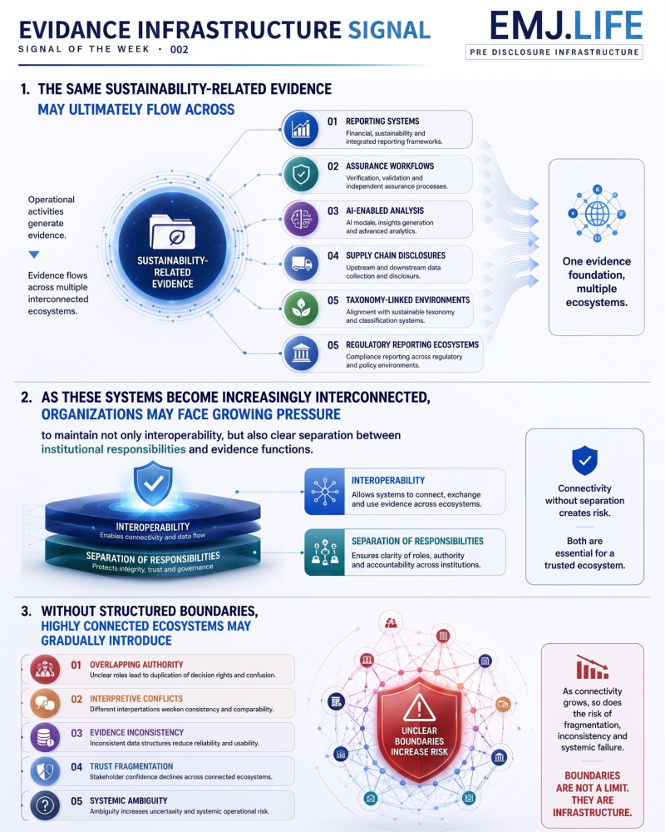
Without structured boundaries, highly connected ecosystems may gradually introduce:
- overlapping authority
- interpretive conflicts
- evidence inconsistency
- trust fragmentation
- systemic ambiguity
As a result, interoperability itself may increasingly depend on governance architecture beneath the reporting layer.
The question may no longer be only:
“How can sustainability systems become interoperable?”
But increasingly:
“How can interoperability remain trustworthy without clear governance boundaries?”

Evidence Infrastructure Signal
Evidence Infrastructure Signal is an ongoing publication series observing structural shifts across interoperability, traceability and sustainability data ecosystems.
Illustrative ecosystem observations only.

