Evidence Infrastructure Signal · 001
Why Interoperability Is Becoming an Infrastructure Problem
May 10, 2026
Across multiple sustainability ecosystems, a similar structural shift is beginning to emerge.
What initially appeared to be separate conversations around sustainability reporting, taxonomy systems, digital disclosures and assurance readiness are increasingly converging toward a deeper infrastructure challenge:
how can sustainability-related evidence remain interoperable across increasingly connected ecosystems?
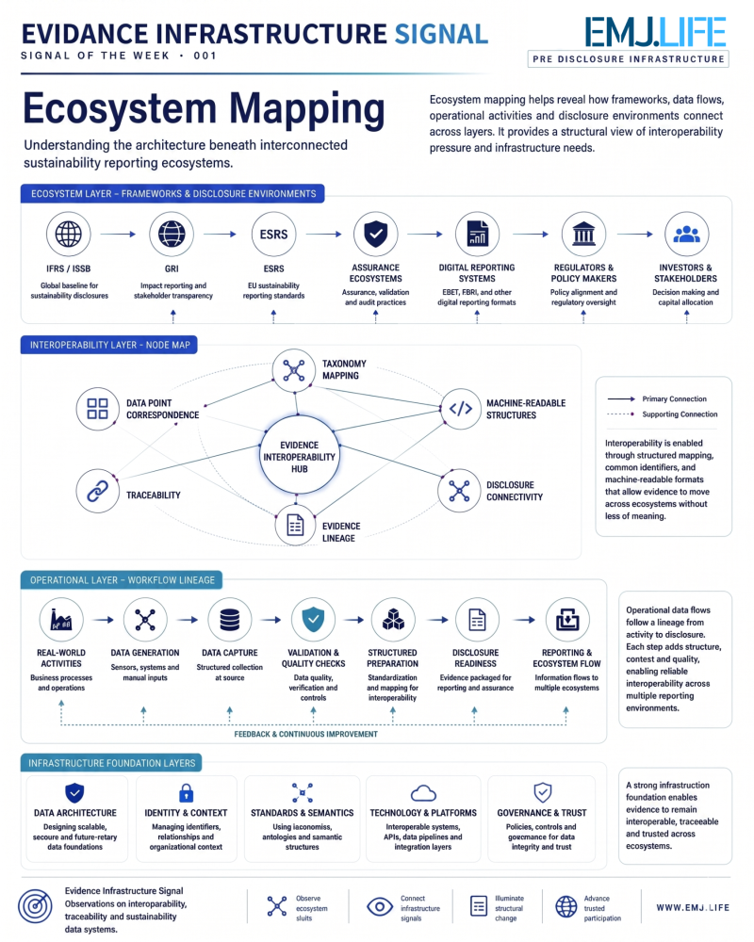
As IFRS/ISSB, ESRS, GRI and supply-chain reporting environments continue evolving simultaneously, organizations are facing growing pressure to maintain consistency across multiple disclosure systems without reconstructing operational evidence separately for each framework.
This appears to be shifting the conversation beyond reporting outputs alone.
The emerging challenge is increasingly about:
- traceability
- evidence lineage
- machine-readable structures
- interoperability
- operational consistency
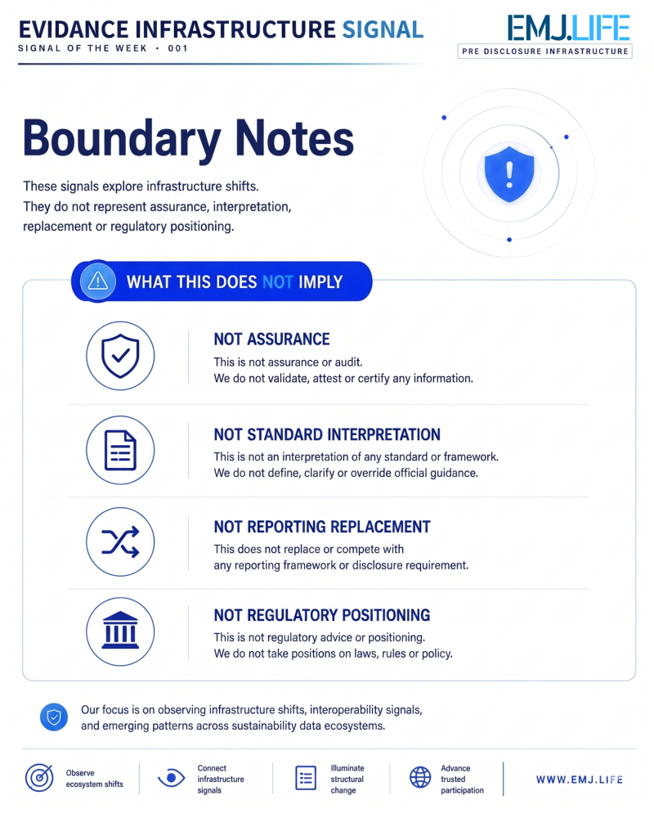

In many cases, the same operational activity may ultimately contribute to:
- sustainability disclosures
- supply chain reporting
- assurance workflows
- taxonomy-linked systems
- product-level environmental reporting
As these ecosystems become more connected, interoperability may gradually evolve from a reporting feature into an infrastructure requirement.
The question may no longer be only:
“How should sustainability information be disclosed?”
But increasingly:
“How can evidence systems remain structurally interoperable across ecosystems?”

Evidence Infrastructure Signal
Evidence Infrastructure Signal is an ongoing publication series observing structural shifts across interoperability, traceability and sustainability data ecosystems.
Illustrative ecosystem observations only.

