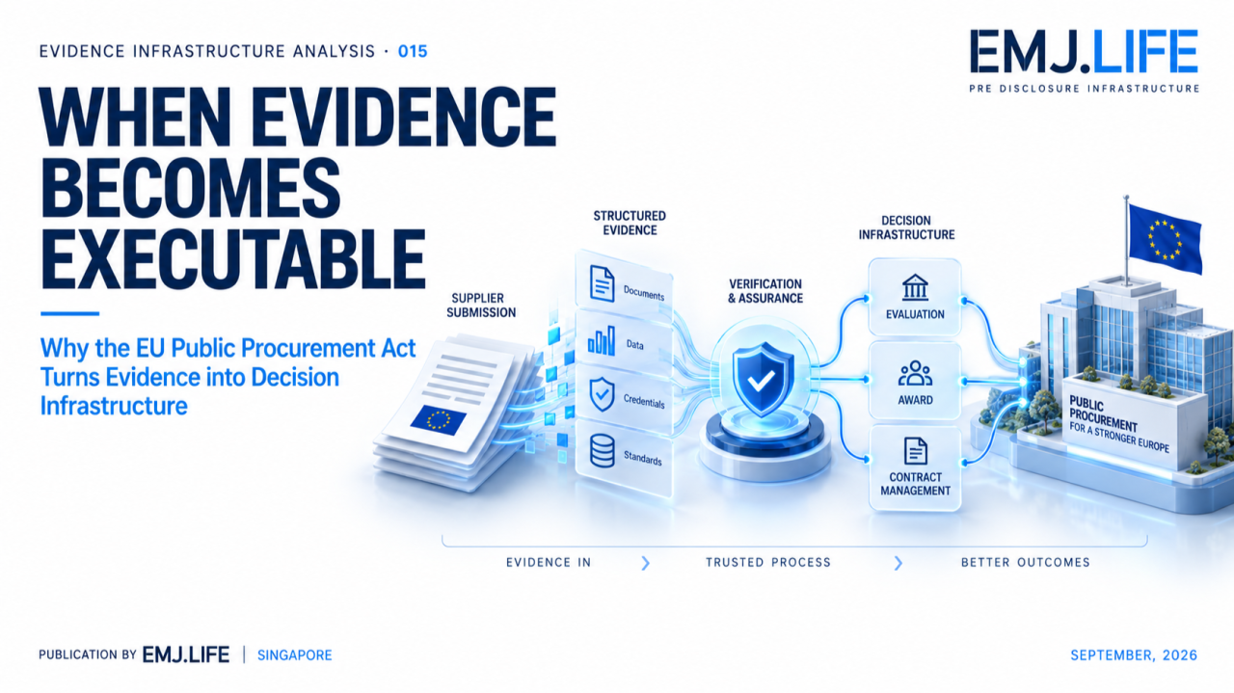
Structured evidence begins to participate in procurement decisions.
VIDENCE INFRASTRUCTURE ANALYSIS · 015
WHEN EVIDENCE BECOMES EXECUTABLE
Why the EU Public Procurement Act Turns Evidence into Decision Infrastructure

Evidence Infrastructure Analysis
Evidence Infrastructure Analysis is an institutional research publication series published by EMJ.LIFE.
The series examines structural developments across global governance, sustainability reporting, interoperability and evidence ecosystems.
Rather than analysing individual regulations or technologies in isolation, each edition explores what institutional developments may reveal about the capabilities required to support trustworthy governance.
Evidence Infrastructure Analysis · 002 examined procurement as an evidence infrastructure problem.
Its central proposition was that procurement was moving beyond static document submission toward operational evidence that must remain attributable, reusable and valid across the procurement lifecycle.
The European Commission's proposed Public Procurement Act, published on 9 September 2026, reveals a further stage of that development.
The proposal does not simply digitise procurement documents.
It introduces an architecture involving:
digital business credentials,
structured evidence,
electronic eligibility,
automated verification,
semantic interoperability,
and procurement data spaces covering contract lifecycle information.
The resulting question is no longer only:
How should procurement evidence remain valid across the lifecycle?
It becomes:
What happens when evidence begins to participate directly in the decision process itself?

Executive Summary
Public procurement has traditionally relied on evidence submitted for human evaluation.
Certificates are provided.
Declarations are checked.
Eligibility is assessed.
Tender information is reviewed.
Award criteria are applied.
Evidence supports the decision.
The proposed EU Public Procurement Act introduces a different architecture.
A digital business credential tool is intended to retrieve structured evidence from relevant national and Union databases.
That evidence can connect to an electronic eligibility service.
Where automated verification is available for an exclusion ground or selection criterion, the proposal states that public buyers shall use that verification for their eligibility decision.
This creates an important structural transition:
Evidence → Verification → Decision
The evidence no longer merely sits behind a decision.
In defined parts of the process, its structured and verified state begins to participate operationally in determining what happens next.
This publication describes that condition as:
Executable Evidence
Executable Evidence does not mean that evidence makes institutional decisions autonomously.
It means that evidence is sufficiently structured, connected and governed that its verified state can trigger or constrain a defined institutional workflow.
This creates a new requirement.
If evidence becomes reusable and operationally actionable, institutions must preserve:
identity,
source,
authority,
version,
semantic meaning,
verification state,
and decision context.
Because reusable evidence creates leverage.
Correct evidence can support repeated decisions.
Incorrect, stale or mischaracterised evidence can propagate just as efficiently.
The next procurement problem may therefore not be document digitisation.
It may be:
Evidence Execution Governance

Opening
A procurement document traditionally has a relatively passive role.
It is submitted.
A person or institution examines it.
A decision is made.
Digital procurement initially changed the medium.
Paper became electronic.
Forms became online.
Notices became machine-searchable.
Submissions moved into eProcurement platforms.
But the institutional sequence remained recognisable:
Evidence → Review → Decision
The proposed Public Procurement Act moves another step.
The Commission describes the current procurement digital ecosystem as fragmented, non-interoperable and insufficiently data-driven.
Its proposed response includes a common digital ecosystem based on an interoperability network, harmonised semantic standards and common specifications.
A central element is an electronic eligibility service built around digital business credentials and company profiles, implementing the once-only principle.
The difference is subtle but important.
Evidence is no longer being designed only to be viewed.
It is being designed to be:
retrieved,
interpreted,
verified,
reused,
and in defined circumstances,
acted upon.
That changes the infrastructure question.

Structural Change
From Document Submission to Executable Evidence
The proposal contains several architectural layers that, taken together, reveal this transition.
Structured Evidence
The digital business credential tool is envisaged as capable of retrieving structured evidence from relevant national and Union databases.
The proposal also identifies other structured evidence that may be relevant, including labels, specifications, security requirements and means of proof for product requirements.
Reusable Credentials
The proposal places the once-only principle at the centre of the digital architecture.
Its digital-ready assessment states that the electronic eligibility service and digital business credential tool should allow an economic operator to share the evidence needed to participate in procurement only once.
Automated Verification
Where the electronic eligibility service provides automated verification of an exclusion ground or compliance with a selection criterion, the proposed Article 28 states that public buyers shall use that verification for the eligibility decision.
Semantic Interoperability
The proposed technical architecture explicitly contemplates:
data format and structure,
configuration and syntax,
a semantic repository,
interoperability requirements,
security and accountability,
and technical audits.
These elements create a different evidence chain:
Evidence Formation → Structured Representation → Credential → Retrieval → Verification → Eligibility State → Institutional Decision
The crucial transition occurs between verification and decision.
Evidence has become operational.
See content credentials
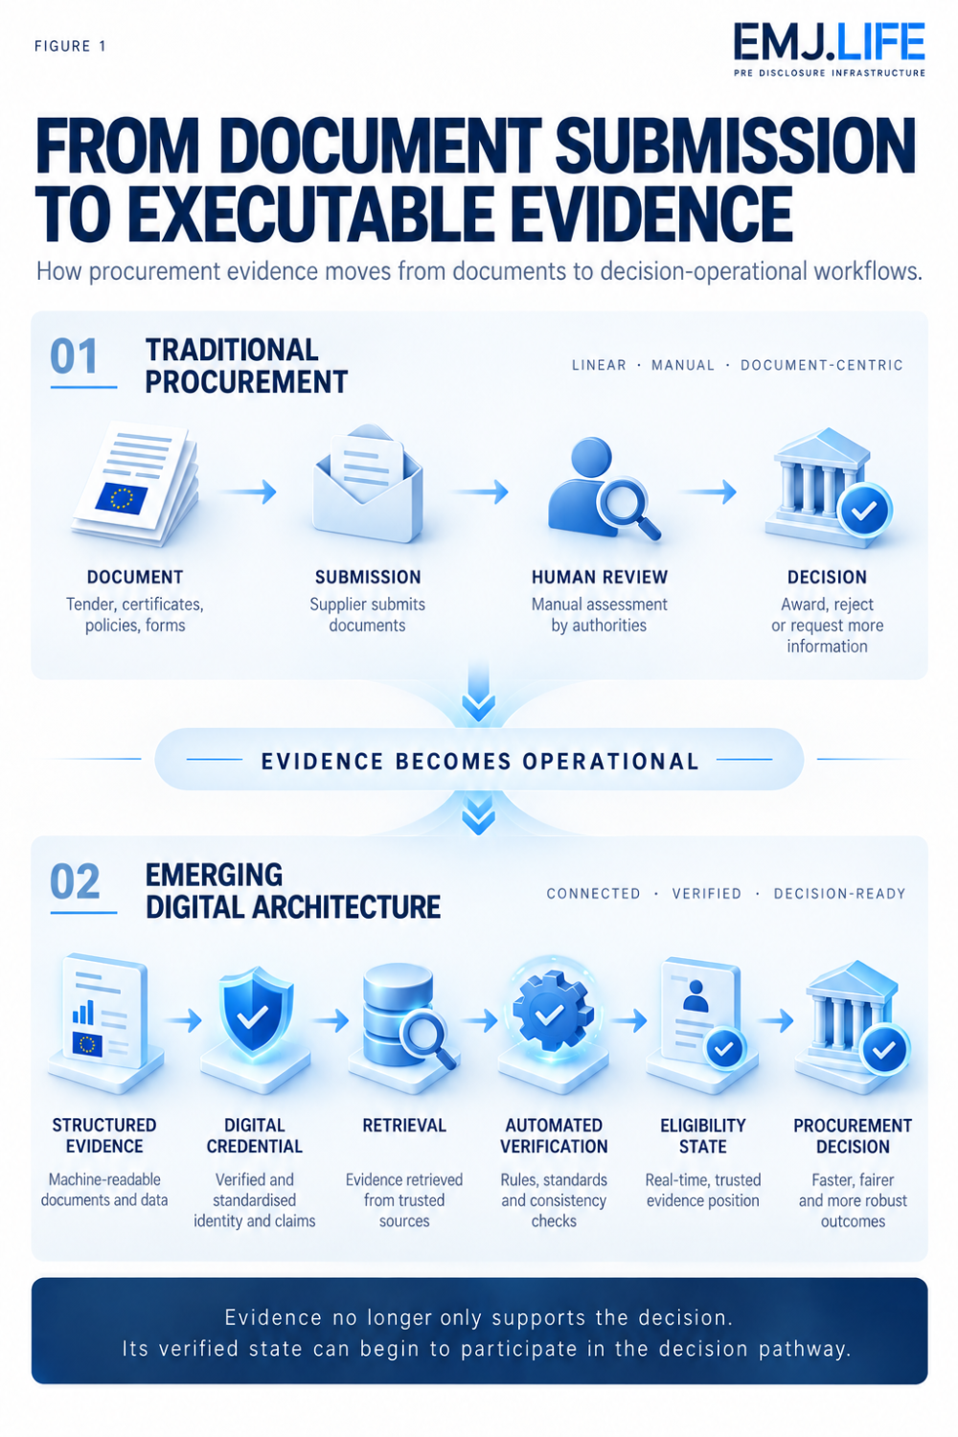
Procurement moves from document submission to executable evidence.

Institutional Signal
Reuse Changes the Risk Model
The once-only principle appears, at first sight, to be primarily an administrative simplification.
Submit evidence once.
Reuse it later.
Reduce repeated documentation.
Reduce procurement burden.
But evidence reuse changes the governance problem.
A document submitted independently into one procurement procedure has a relatively contained failure boundary.
A reusable evidence object can travel.
It can support multiple procedures.
Multiple eligibility checks.
Potentially multiple institutional processes.
That creates leverage.
It also creates propagation risk.
Consider an evidence object whose:
source changed,
legal status changed,
version expired,
ownership changed,
underlying record was corrected,
or semantic interpretation became outdated.
If the object remains reusable without corresponding evidence-state governance, the same defect can propagate into multiple downstream decisions.
This creates an important principle:
Once-only evidence requires continuous validity.
The institutional objective cannot simply be:
collect once.
It must become:
establish once, verify appropriately, reuse under controlled validity.
Otherwise the once-only principle can create a different failure mode:
Once Wrong, Reused Everywhere
This is not an argument against evidence reuse.
It is the reason reusable evidence needs stronger governance.

Evidence Infrastructure Perspective
Executable Evidence Requires More Than Structured Data
Structured evidence is necessary for automation.
But structure alone does not establish institutional reliability.
For evidence to participate safely in a decision pathway, several conditions must remain connected.
1. Evidence Identity
The system must know which evidence object is being acted upon.
2. Source Authority
The issuing database, credential source or evidence authority must remain identifiable.
3. Subject Binding
Evidence must remain connected to the correct economic operator, product, entity or other relevant subject.
4. Temporal Validity
The system must know whether the evidence remains current at the moment of decision.
5. Semantic Stability
Machines and institutions must interpret the evidence consistently.
This makes the proposal's attention to data formats, semantic repositories and interoperability requirements institutionally significant.
6. Verification State
The distinction between:
evidence exists
and
evidence has been verified for this defined purpose
must remain explicit.
7. Decision Binding
The system must preserve which evidence and verification state supported which institutional decision.
8. Auditability
If an automated verification contributes to eligibility, the relationship between evidence, verification and decision must remain reconstructable.
Together, these conditions create:
Evidence → Identity → Authority → Validity → Verification → Decision → Audit Trail
This is the infrastructure beneath executable evidence.

Strategic Procurement Raises the Stakes
The proposed Act is not only a digital simplification initiative.
It also seeks to strengthen procurement as a strategic policy instrument.
The Commission describes the proposal as integrating strategic objectives into procurement design, award and contract performance, including environmental objectives, socially responsible procurement, innovation, resilience and economic security.
That matters for evidence infrastructure.
The more procurement decisions depend on characteristics beyond price, the more diverse the supporting evidence becomes.
Environmental performance.
Social criteria.
Supply-chain information.
Origin.
Security.
Resilience.
Technical specifications.
Life-cycle costs.
Some of these claims may directly affect market access or tender evaluation.
Evidence quality therefore becomes part of competitive access.
The proposal's life-cycle costing provisions illustrate the point.
Where environmental and climate externalities are included, their monetary value must be capable of being determined and verified. Public buyers must indicate the data tenderers should provide and the method used to determine life-cycle costs, while methods for environmental and climate externalities must rely on objectively verifiable and non-discriminatory criteria.
This creates another transition:
Sustainability evidence is moving closer to procurement decision logic.
The issue is no longer simply whether a company publishes sustainability information.
The same underlying evidence may increasingly influence whether and how that company competes for public contracts.

From Eligibility to the Procurement Lifecycle
The proposal also extends the evidence architecture beyond the point of award.
Each Member State would establish or designate a National Public Procurement Data Space as a central access point for procurement and contract lifecycle data.
Those national environments would feed a Union-level Public Procurement Data Space managed by the Commission.
The stated purpose includes more systematic monitoring of procurement markets, competition, strategic procurement outcomes, cross-border participation, SME access, integrity, resilience and security of supply.
This changes the temporal structure of procurement evidence.
The relevant lifecycle becomes:
Eligibility → Tender → Award → Contract → Performance → Monitoring → System-Level Analysis
Evidence Infrastructure Analysis · 002 identified the importance of maintaining evidence across procurement rather than treating procurement as a one-time documentation event.
The proposed Public Procurement Act does not replace that analysis.
It strengthens the reason for it.
As procurement becomes more data-driven, evidence continuity becomes relevant not only to one procurement decision, but to the wider institutional monitoring architecture that follows.
See content credentials
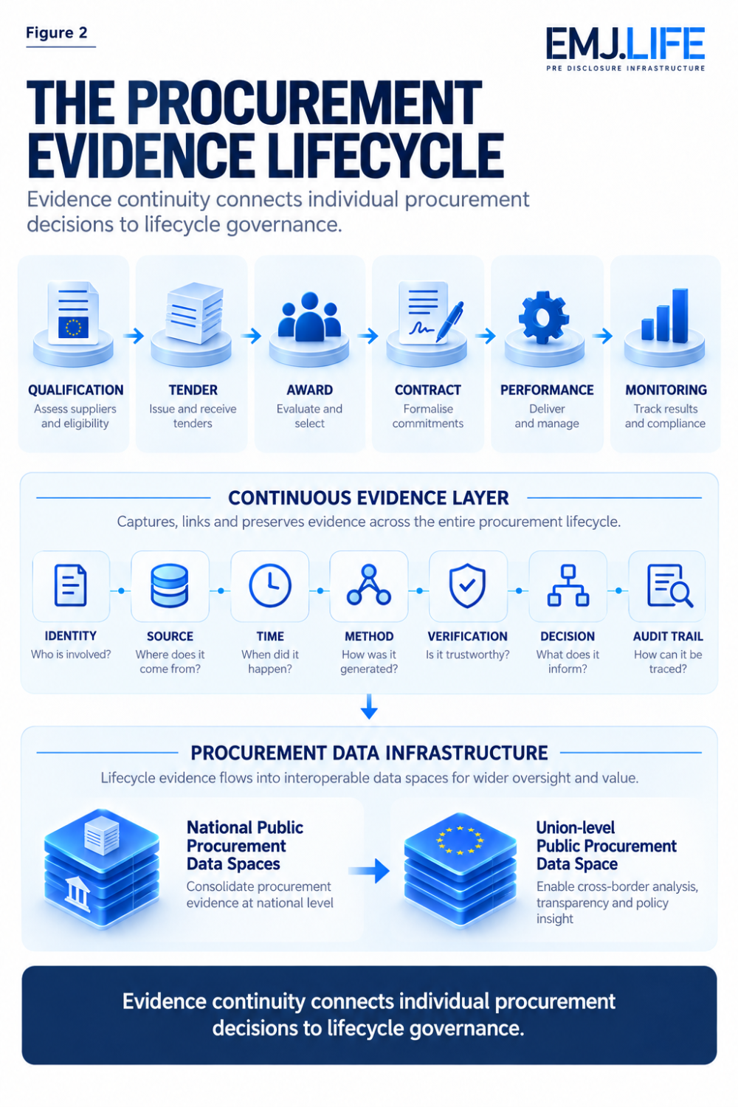
Evidence continuity connects procurement decisions across the lifecycle.

The Institutional Boundary
Executable Does Not Mean Autonomous
The concept of Executable Evidence requires a careful boundary.
The Public Procurement Act proposal does not establish a general system in which machines autonomously decide procurement outcomes.
Nor does automated verification eliminate institutional responsibility.
The proposal itself limits automated verification to defined contexts and retains extensive rules governing public buyers, procedures, evidence and rights.
The relevant shift is narrower.
Evidence is becoming structured enough that:
a verified evidence state can become an operational input into a legally governed decision process.
That distinction matters.
Executable Evidence is therefore not:
autonomous evidence,
self-executing law,
or
AI procurement.
It is evidence whose machine-usable state has institutional consequences.
The governance requirement therefore remains human and institutional:
Who defines the evidence?
Who controls the source?
Who determines the verification logic?
What happens when records conflict?
How is a decision challenged?
How is evidence corrected?
How does corrected evidence propagate?
The more executable evidence becomes, the more important these questions become.

From Evidence Infrastructure to Decision Infrastructure
There is a deeper implication.
Evidence infrastructure is usually understood as supporting institutional decisions.
But when structured evidence can be retrieved automatically, verified through defined services and reused across processes, the relationship changes.
Evidence infrastructure begins to sit inside the operational path of the institution.
This creates:
Decision Infrastructure
Decision Infrastructure is not the replacement of institutional judgment by data.
It is the architecture that determines:
which evidence reaches a decision,
in what state,
under which authority,
through which verification process,
and with what reconstructable lineage.
That architecture becomes particularly important when decisions determine:
market eligibility,
public expenditure,
competitive access,
and the application of strategic environmental or social criteria.
The quality of evidence infrastructure therefore begins to influence the quality of the institutional decision itself.

Closing Reflection
Public procurement has been becoming digital for years.
That alone is not the signal.
The deeper transition appears when digitisation changes the institutional role of evidence.
A scanned document is digital.
A structured evidence object is different.
A reusable credential is different again.
A verified credential that participates in an eligibility decision represents another stage entirely.
The proposed EU Public Procurement Act brings these layers increasingly close together:
structured evidence,
digital credentials,
once-only reuse,
automated verification,
semantic interoperability,
lifecycle data,
and procurement monitoring.
This does not make evidence autonomous.
It makes evidence more operational.
That distinction may become increasingly important across digital governance.
EIA · 002 asked what happens when procurement becomes an evidence infrastructure problem.
EIA · 015 asks what happens next:
What happens when that evidence infrastructure begins to participate in the decision itself?
The answer requires more than digitisation.
It requires evidence whose:
identity is persistent,
source is authoritative,
meaning is stable,
validity is current,
verification is governed,
and decision lineage remains reconstructable.
That is the transition from documentation to:
Executable Evidence
And when evidence becomes executable:
Evidence governance becomes part of decision governance.

Official Sources
This publication is primarily informed by:
European Commission, COM(2026) 590 final, Proposal for a Regulation on Public Contracts and Concessions, Public Procurement Act, 9 September 2026. The proposal seeks to replace Directives 2014/23/EU, 2014/24/EU and 2014/25/EU with a single directly applicable Regulation.
Relevant provisions and supporting sections include:
Article 28, electronic eligibility and automated verification.
Article 29, connection of databases and structured evidence.
Article 99, life-cycle costing and objectively verifiable environmental and climate externalities.
Article 133, electronic eligibility technical arrangements, including data structure, semantic repository, interoperability and technical audits.
Article 134 and related provisions, National and Union-level Public Procurement Data Spaces and contract lifecycle data.
The concepts Executable Evidence, Evidence Execution Governance, and Decision Infrastructure represent EMJ.LIFE's institutional interpretation of the architecture emerging from the proposal.
They are not terminology adopted by the European Commission and are not presented as legal interpretations or as provisions of an enacted Regulation.

